Types of Terminology
# Source: AI Source: Provided by: [Data Path: Persons Table -> ID Column: 1, Name_En Column: Motasem Essam] -> From: [Chatgpt (GPT-4-turbo)] on [7/31/2025]
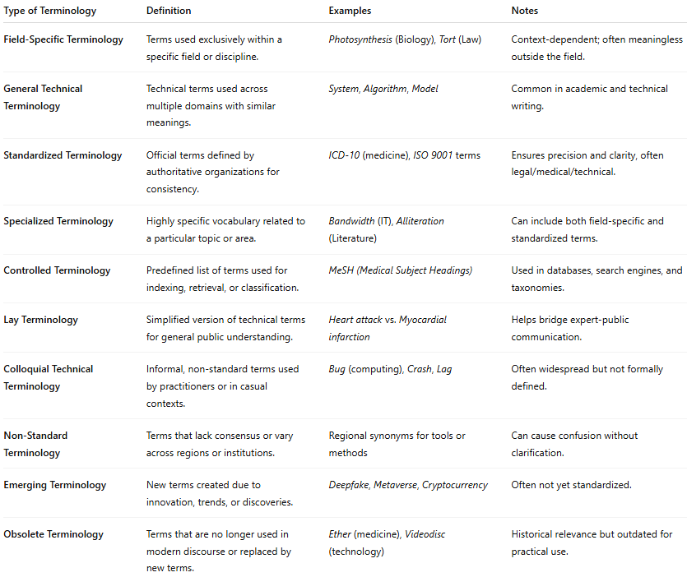

Type of Terminology | Definition | Examples | Notes
Field-Specific Terminology | Terms used exclusively within a specific field or discipline. | Photosynthesis (Biology), Tort (Law) | Context-dependent; often meaningless outside the field.
General Technical Terminology | Technical terms used across multiple domains with similar meanings. | System, Algorithm, Model | Common in academic and technical writing.
Standardized Terminology | Official terms defined by authoritative organizations for consistency. | ICD-10 (medicine), ISO 9001 terms | Ensures precision and clarity, often legal/medical/technical.
Specialized Terminology | Highly specific vocabulary related to a particular topic or area. | Bandwidth (IT), Alliteration (Literature) | Can include both field-specific and standardized terms.
Controlled Terminology | Predefined list of terms used for indexing, retrieval, or classification. | MeSH (Medical Subject Headings) | Used in databases, search engines, and taxonomies.
Lay Terminology | Simplified version of technical terms for general public understanding. | Heart attack vs. Myocardial infarction | Helps bridge expert-public communication.
Colloquial Technical Terminology | Informal, non-standard terms used by practitioners or in casual contexts. | Bug (computing), Crash, Lag | Often widespread but not formally defined.
Non-Standard Terminology | Terms that lack consensus or vary across regions or institutions. | Regional synonyms for tools or methods | Can cause confusion without clarification.
Emerging Terminology | New terms created due to innovation, trends, or discoveries. | Deepfake, Metaverse, Cryptocurrency | Often not yet standardized.
Obsolete Terminology | Terms that are no longer used in modern discourse or replaced by new terms. | Ether (medicine), Videodisc (technology) | Historical relevance but outdated for practical use.

